Wireframe Documentation

Flight Fare Prediction

Project Member: Rohit Atnoor

Mentor: Ineuron

Latest Version: 1.7

Last Data of Revision: 19/09/2023

**Home Page**

We have divided Flight Price Prediction Homepage into Two Sections: -

1. First thing anyone will see is a pop-up window on Homepage which will show the details about the project.

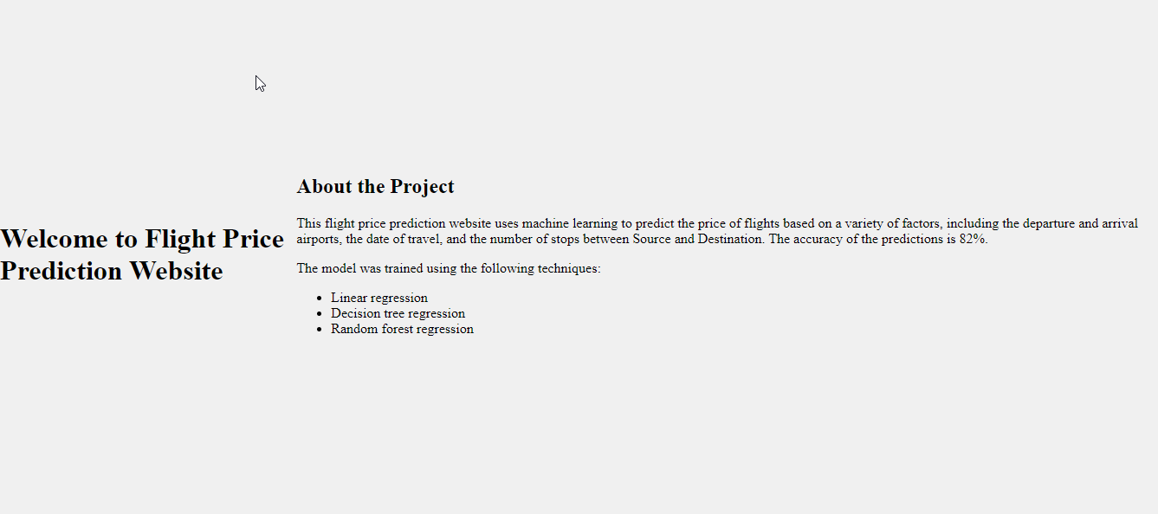

1. The User will encounter with another pop-up window asking for User details.

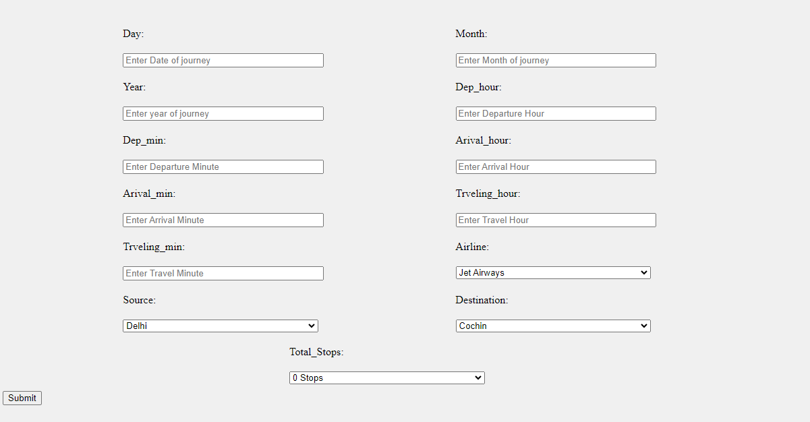

1. Based on User’s input, our Flight Price Prediction System will recommend recipes to User on Homepage itself. A sample view of Homepage showing results is below:

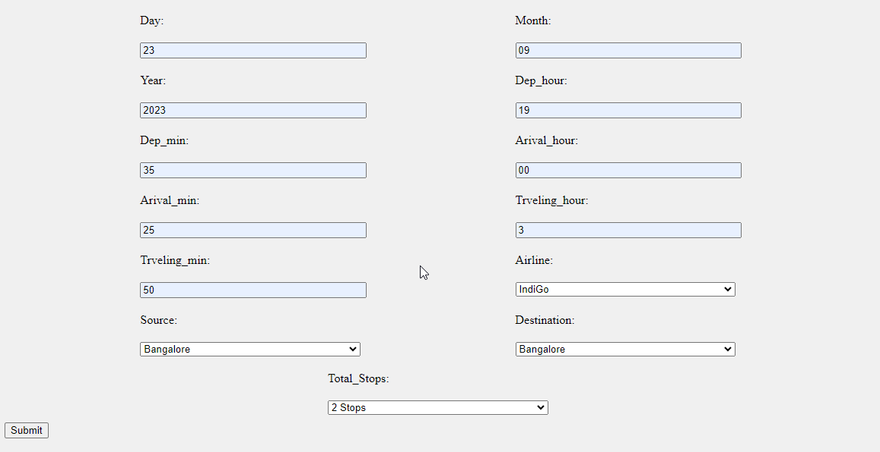

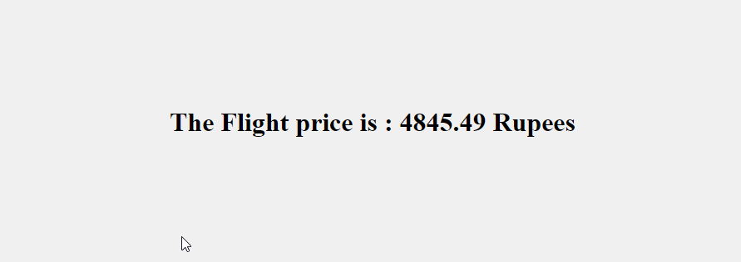

**Complete and simple Web page Wireframe**

